**How to Make a Peanut Butter and Jelly Sandwich**

**Definitions[1] and Ingredients**

**Sandwich:** Two or more slices of bread or the like with a layer of meat, fish, cheese, etc., between each pair.

**Peanut Butter:** A paste made from ground roasted peanuts, used as a spread or in cookery.

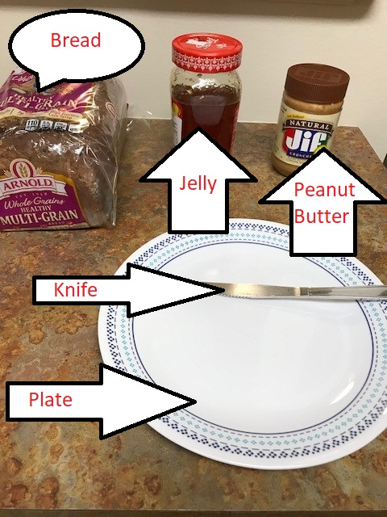**Jelly:** A food preparation of a soft, elastic consistency due to the presence of gelatin, pectin, etc., especially fruit juice boiled down with sugar and used as a sweet spread for bread and toast, as a filling for cakes or doughnuts, etc.

**Bread:** A kind of food made of flour or meal that has been mixed with milk or water, made into a dough or batter, with or without yeast or another leavening agent, and baked.

**Plate:** A shallow, usually circular dish, often of earthenware or porcelain, from which food is eaten.

**Knife:** an instrument for cutting, consisting essentially of a thin, sharp-edged, metal blade fitted with a handle.

**Assumptions Made and Tips for Successful Results**

* It is assumed that you already have all the listed items.
* For this process documentation, the type of bread, peanut butter and jelly was left unspecified on purpose since this is a general description for a basic peanut butter and jelly sandwich. The results will vary depending on the ingredients that are used each time. There are so many different kinds of breads, peanut butter spreads and jellies to choose from depending on one’s taste.
* Spreading peanut butter or jelly onto a bread slice can be challenging for many reasons such as the freshness of the bread or peanut butter being too dry and cold. Using fresh bread or toasting the bread can ease this process as well as warming up the peanut butter in a microwave for 30 seconds can also be helpful. Spreading the peanut butter carefully and gently is important not to tear the bread to shreds. I would suggest to grasp the knife and turn it in a way that it is almost parallel to bread when gently spreading the peanut butter or jelly evenly onto the bread.
* If you do not like bread crust, when taking out two slices of bread from the bag or when cutting slices from the bread loaf, you can skip the first slice of bread since they are usually too dry. If you do not like crusts around the slices, you can also crust them off entirely.
* If you are preparing more than one peanut butter and jelly sandwich, instead of repeating the steps in the same order from beginning to end to prepare one sandwich at a time, you can repeat each step as many sandwiches as you want to prepare and then go to following steps for each sandwich. This way you can set up your assembly line and save time.
* Cleaning the kitchen countertop and utensils before and after preparing the peanut butter and jelly sandwich is an essential step for sustaining a healthy and hygienic setting in food preparation.

**Step-1**

For the first step, you need two slices of bread:

* If the bread you have is a pre-sliced bread, then open the bag by removing the twist tie and take out two slices of bread and place them on the plate side-by-side.
* If the bread loaf you have is not a pre-sliced bread, then grasp the knife from the handle with one hand and grasp the bread loaf with the other hand placing it on a hard surface like a kitchen countertop or cutting board, hold the knife above the bread, sharp edge touching the beard and slide the knife back and forth until you cut your first slice. Repeat this for the second slice. Each slice can be about a half an inch thick like pre-sliced breads and they are usually square shaped and about 4.5 inches by 4.5 inches. Now you have two bread slices, place them on the plate side-by-side.

**Step-2**

For the second step, you need to spread peanut butter and jelly on the bread slices that you prepared in the previous step.

* In order to remove the lids from the peanut butter and jelly jars, grasp the peanut butter jar with one hand and with the other hand twist the jar lid counter-clockwise to open. Continue until the lid gets loose and then lift the lid to open the jar. Repeat this step for the jelly jar as well. After you open both jars, set them aside.
* In order to get some peanut butter from the jar to spread onto one of the bread slices, first grasp the peanut butter jar with one hand and the knife with the other hand holding from its handle and insert the knife inside the peanut butter jar. You can get some peanut butter by moving your hand holding the knife in a circle inside the jar couple of times. Try to get approximately two tablespoons of peanut butter but if you love to have more, consider that it would be harder to manage when you are eating. Lift the knife out of the jar and turn it in a way that it is almost parallel to the bread slice and gently spread the peanut butter to one of the bread slices covering the one side of the bread as evenly as possible. You can repeat this step until you get the desired amount of peanut butter to cover the slice. Place the bread on the plate, peanut butter side facing up.
* In order to get some jelly from the jelly jar to spread onto the other bread slice, first grasp the jelly jar with one hand and the knife with the other hand from its handle. You can use a different knife if you do not want any peanut butter getting into your jelly jar. Insert the knife inside the jelly jar to get some jelly on the knife. You can do it by moving your hand holding the knife in a circle inside the jar couple of times. Try to get approximately one tablespoon of jelly. You can increase the amount of jelly to your taste but consider that it would be harder to manage when you are eating. Lift the knife out of the jar and turn it in a way that it is almost parallel to the unused bread slice and gently spread the jelly as evenly as possible onto the bread slice. You can repeat this step until you get the desired amount of jelly. Place the bread on the plate, jelly side facing up.

**Step-3**

For the third step, you need to combine both slices of bread together. Pick the peanut butter covered slice of bread from the sides and flip and press it on top of the jelly covered slice of bread, lining up the edges, in such a way that peanut butter and jelly touch together. You have done with your peanut butter and jelly sandwich.

1. All definitions are from http://www.dictionary.com, accessed on October, 22, 2017.